Job Description

Job Title Personal Development Manager (PDM)
Department Member Services
Reports to Lead Personal Development Manager

Job Purpose

Deliver a Personal Development & Welfare Programme (PDWP) to male and female professional cricketers, county academy players and past players within a specified region. Work as part of the PCA PDWP national team, overseen by the PCA Director of Development and Welfare. Support and work closely with the PCA’s expert referral network and all staff at the First Class County Club (FCCC), Regional Women’s Centre and the England and Wales Cricket Board (ECB).

Context

The PCA’s PDWP is a personalised support service which recognises that cricket is likely to be the main focus in a player’s life while they are playing, and that playing cricket represents a relatively short part of their working life.

The PDWP is a person-centred programme that supports players through key transitions in their lives. It facilitates learning and personal development, and helps players to maximise their potential as cricketers and people in their preparation for life beyond playing.

The PDMs will develop good professional relationships with County CEOs, Directors of Cricket, Regional Directors, coaches, support staff, family and agents. PDMs are required to maintain high levels of independence, integrity and confidentiality (in line with ethics/code of conduct). PDMs will also be held accountable to agreed programme specific PCA deliverables and measurables.

The Personal Development and Welfare Programme (PDWP)

The aim of the PDWP programme is “to enable individuals to excel and develop sustainable performance within and outside cricket”.

The PDWP model places our members at the centre of all we do. The four pillars of support, delivered by PDMs, are outlined overleaf:

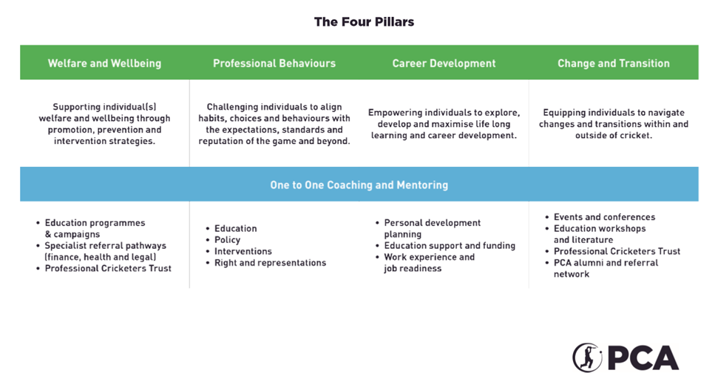

Principal Responsibilities

Personal Development & Welfare
Be available to support players across the four pillars listed above, within the PDM’s designated region of responsibility, both proactively and reactively to meet the changing needs of male and female current and former players.

- Relationships
Form strong and trusting relationships with players, relevant County Cricket Clubs and Regional Women centre management, other members of the PCA network and PDM team.

- Winter programmes
With the other members of the PDM team, develop and deliver a programme of winter activity (to be a mix of personal, local, regional and national work) to take advantage of the agreed time commitment for personal development according to the players’ specific need and level of contract (Rookie or Pro).

- Workshops
Development, co-ordination and delivery of the education programmes/workshops for both county academy players, county and regional centre professional players, as outlined in the PCA’s deliverables and measurables document. Maintaining records and evidence of this delivery for the annual ECB Science and Medicine audit.

- Mandatory education programmes
Ensure full county and regional centre squad participation in joint PCA/ECB mandatory education and training modules. Play an integral role in the design and delivery of the PCAs flagship education projects e.g. Rookie Camp, Futures Awards and Futures Conference.

Collaboration

Collaborate closely with the PDM team, ECB England performance pathway staff, and the wider PCA expert referral network to ensure players have the best support and education available.

Player services
Attend preseason county and regional centre visits, player representatives’ meetings and other appropriate PCA team meetings and events. Assist with the co-ordination of agreed player projects where directed by the Lead PDMs.

- Athlete Management System
Keeping up to date records of player engagement and monthly activity for the generation of accurate reports.

Knowledge Skills and Experience

Essential:

- 1-2 years’ experience working in a related field.
- Demonstrated experience of guiding and supporting people through various transitions, educational and vocational pathways.
- An in-depth understanding of the issues facing high performers, the impact on their welfare and wellbeing and the challenges of career change.
- Working with people, ability to relate well to people at all levels; manage conflict effectively; listen, consult with others and communicate proactively; support and care for others; possessing high levels of self-awareness.
- Demonstrated experience of developing, planning and delivering individual or group support programmes to address either the career, professional development or wellbeing needs of athletes or high performers.
- Proven experience of building and leveraging relationships to influence, challenge and work effectively with a wide range of stakeholders.
- Demonstrated high levels of experience in planning and facilitating workshops across a broad range of topics and age groups.
- Strong desire to excel at whatever tasks are at hand, seeking to achieve high levels of professionalism.
- Quick to respond to problems and devise solutions which achieve objectives, making timely decisions and guiding actions in the context of the bigger picture.
- Passionate about maintaining and bettering standards of service for cricketers.
- Experience of working with young & adult performers.
- Prepared to work flexible hours and travel throughout a designated region.
- Computer literacy, including MS office.
- Full and clean driving licence.

Desirable:

- Knowledge of essential operations of the PCA and its departments.
- Good undergraduate honours degree in a related field.
- Knowledge of the structure of the ECB and the broader cricket landscape.
- Experience of playing sport at an elite level.
- Postgraduate Qualifications in a related field.
- Knowledge of the UK education system.
- Business acumen and knowledge in the areas of recruitment and employability.
- Qualifications in career advice or counselling.
- Institute of Leadership and Management (ILM) Level 5 or above in Coaching and Mentoring.
- The Level 3 Certificate in Talented Athlete Lifestyle Support (TALS) qualification.
- Accreditation to deliver Myers Briggs Type Indicator (MBTI), Insights, Mindflick, Lumina Spark or other relevant psychometric tools.
- A commitment to undertake continued professional development in order to continually strive for excellence within this field.

Working Relationships

- All PCA staff.
- Current county academy players, current male and female professional players and past cricketers and their families.
- First Class County and regional centre CEO’s, Directors of Cricket, Head Coaches, Academy Directors & Support Staff.
- Key stakeholders at the England & Wales Cricket Board (ECB).
- PCA Commercial Partners.
- External referral network (Legal, Mental Health and stakeholders).
- Recruitment partners.
- External partner organizations & facilitators.
- Federation of International Cricket Associations (FICA).
- The Professional Players Federation (PPF).
- World Players’ Association (WPA).
- EU Athletes Organisation.

